Syeda Reeha Quasar

14114802719

4C7

Aim

Write the SQL queries to implement DATE and MONTH commands.

Experiment - 7

DATABASE MANAGEMENT SYSTEMS LAB

# **EXPERIMENT – 7**

## **Aim:**

Write the SQL queries to implement DATE and MONTH commands.

## **Tools Used:**

MariaDB

## **Procedure/ Queries:**

In SQL, we have many data types available, which we can use as the date in our table. Some of them popularly being- ‘YYYY-MM-DD’ and ‘DD-MM-YYYY’.

In some scenarios, we also have time stored in our database with the date, in such cases, we need tools to separately access the time and the date. This is where the SQL time and functions come in handy.

Also, as a beginner, one should be very careful when using date or DateTime in the database as these are very likely to give exceptions if not dealt with properly.

**Formats of Date Time in SQL:**

**DATE –** YYYY-MM-DD  
**DATETIME –** YYYY-MM-DD HH:MI:SS  
**TIMESTAMP –** YYYY-MM-DD HH:MI:SS  
**YEAR –** YYYY or YY

Why do we need Date and Time Functions?

We have plenty of functions available for date and time in SQL. These are provided to make sure smooth access of the date and time module while making and accessing a SQL database.

Some of the most popular date and time functions are as follows:

|  |  |  |
| --- | --- | --- |
| **Sr.No** | **Function** | **Description** |
| 1 | NOW( ) | Displays the current date and time. |
| 2 | CURDATE( ) | Displays the current date. |
| 3 | CURTIME( ) | Displays the current time. |
| 4 | DATE( ) | Displays the date from the Date/DateTime expression. |
| 5 | EXTRACT( ) | Displays selected part i.e. date/time. |
| 6 | DAY( ) | Displays the day from the given date. |
| 7 | MONTH( ) | Displays the month from the given date. |
| 8 | YEAR( ) | Displays the year from the given date. |
| 9 | DATE_ADD( ) | Displays date after adding the given interval. |
| 10 | DATE_SUB( ) | Displays date after subtracting the given interval. |
| 11 | DATEDIFF( ) | Displays the interval between two dates. |
| 12 | DATE_FORMAT( ) | Displays the date/time data in various formats available. |

# DATE

1. CREATE TABLE employees (dates DATE);  
     
   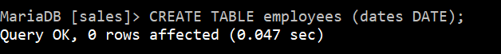
2. INSERT INTO employees VALUES ("2010-01-12"), ("2011-2-28"), ('120314'),('13*04*21');  
     
   
3. select * from employees;   
     
   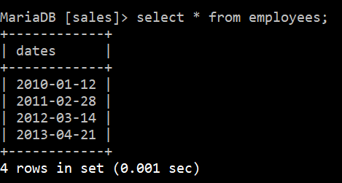

# MONTH

1. SELECT MONTH('2014-05-19');  
     
   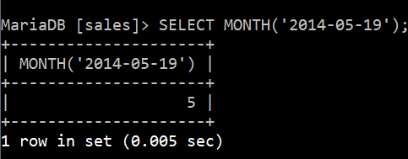
2. SELECT MONTH('2014-05-19 09:04:05');  
     
   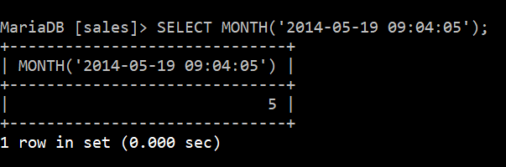
3. SELECT MONTH('2013-11-23');  
     
   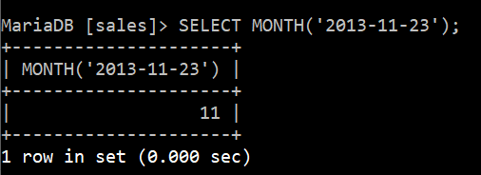
4. SELECT MONTH(CURDATE());  
     
   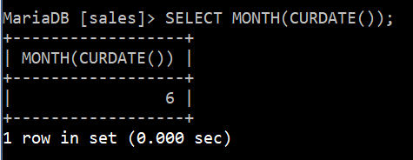

**SELECT** '2008-12-31 23:59:59' + INTERVAL 1 **SECOND**;

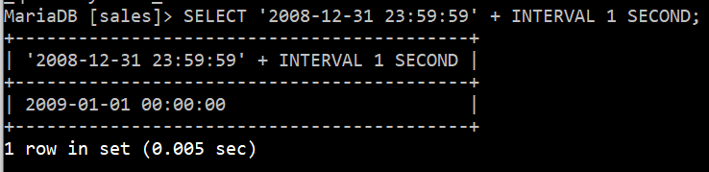

SELECT NOW();  
  
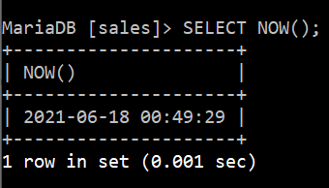

SELECT CURDATE();

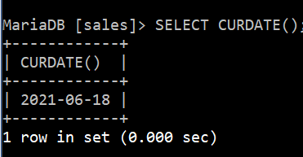

SELECT CURTIME();

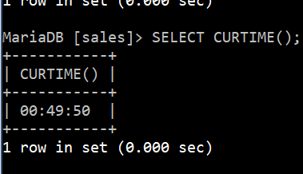

SELECT DATEDIFF('2017-01-13','2017-01-03') AS DateDiff;

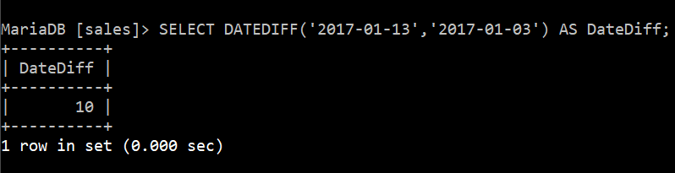

SELECT DATE_FORMAT(NOW(),'%d %b %y');

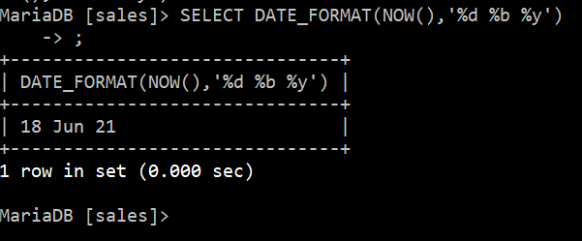

# VIVA QUESTIONS

## Q1. What is DATE command?

Ans.

MySQL DATE() takes the date part out from a datetime expression.

The **DATE**() **function** extracts the **date** part from a **datetime** expression.

## Q2). What is month Function?

Ans.

The **MONTH**() function returns an integer value which represents the **month** of a specified date. The **MONTH**() function takes an argument which can be a literal date value or an expression that can resolve to a TIME , DATE , SMALLDATETIME , DATETIME , DATETIME2 , or DATETIMEOFFSET value.

## Q3). What is syntax of Date Command?

Ans.

**SQL** Server comes with the following data types for storing a **date** or a **date**/time value in the database: **DATE** - format YYYY-MM-DD. **DATETIME** - format: YYYY-MM-DD HH:MI:SS. SMALLDATETIME - format: YYYY-MM-DD HH:MI:SS. TIMESTAMP - format: a unique number.

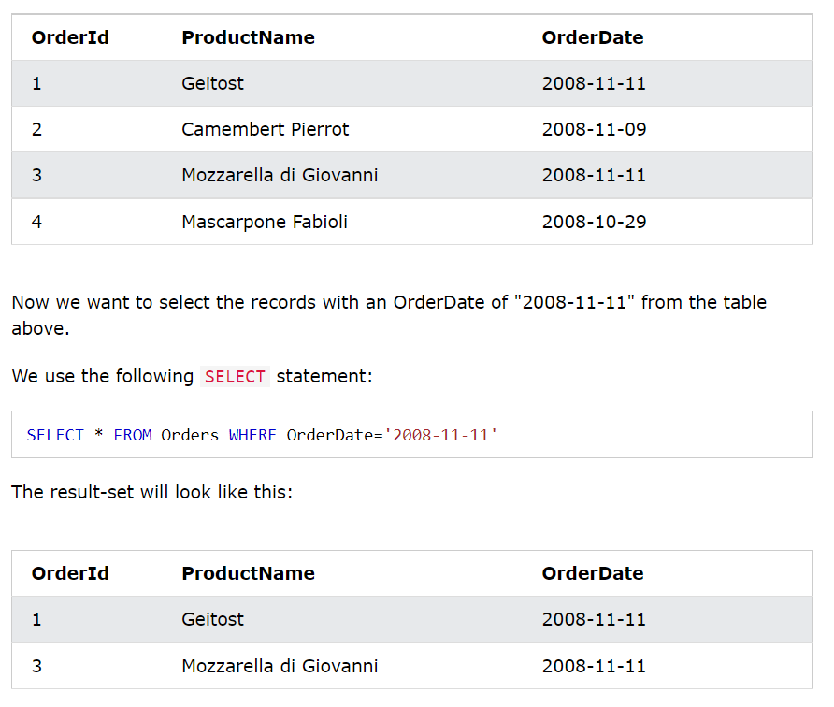

## Q4). Write function for month command.

Ans.

**SQL** Server **MONTH**() Function

The **MONTH**() function returns the **month** part for a specified date (a number from 1 to 12).

## Q5). What is difference between DATETIME and TIMESTAMP command?

Ans.

**TIMESTAMP** is four bytes vs eight bytes **for DATETIME**. **Timestamps** are also lighter on the database and indexed faster. The **DATETIME** type is used when you need values that contain both date and time information. MySQL retrieves and displays **DATETIME** values in 'YYYY-MM-DD HH:MM:SS' **format**.

**TIMESTAMP** value converts from the current time to UTC and vice-versa while **DATETIME** does not do any conversion. TIMESTAMPdiffers with current time zone settings while **DATETIME** remains constant. **TIMESTAMP** data can be indexed while the **DATETIME** data cannot.